We Can Become ECK Masters!

Click or tap to enter a date.   
**Ages 5-7**

**When**Click or tap here to enter a time.

**Where**Click or tap here to enter a location.

**Program Length:** 2 ½ hours

**Program Description**One day we will all be Coworkers with God—so full of divine love that we give it out to all life, just like the ECK Masters do. Have fun exploring who the ECK Masters are and how they help us. Get keys that can help you become an ECK Master too!

**Spiritual Purpose and Benefits**

* Youth explore who the ECK Masters are and how they help us grow.
* Youth imagine themselves helping others as a Coworker with God in a finger puppet play.

**Program Overview**

* Pre-Session Volunteer Meeting
* Welcome Activity– ECK Master coloring sheets
* HU Song and Group Meeting
* Get to Know the ECK Masters– Spiritual Exercise and Memory Game
* ECK Master Puppet Theater
* Gratitude Garden
* Clean Up, Sharing, and Feedback

Pre-Session Volunteer Meeting (45 minutes)

* Introductions and HU Song
* Brief review of volunteer roles
* Safety review
* Program review
* Questions and answers

🗎 ***Note to Room Leader and Activity Leaders:* Please share program activities and directions in your own wonderful words, using language that 5-7 year old children will understand. Thank you!**

Welcome Activity– ECK Master coloring pages (up to 30 minutes)

Supplies

* ECK Master coloring pages
* Crayons, markers, colored pencils, pens
* Group Leaders welcome youth as they arrive.
* Youth can choose an ECK Master coloring sheet to color.
* Group Leaders can chat with youth to introduce ECK Masters: *Do you know who the ECK Masters are? Have you seen their pictures before? They are spiritual teachers who can help us.*

Welcome, HU Song and Group Meeting (15 minutes)

🗎 Note to Group Leaders: Please sit with youth during the large group HU and Guidelines/Rules.

* Youth and volunteers come together in a large circle.
* The Room Leader welcomes the youth.
* Everyone takes a turn to share their name and something they like to do.
* Introduce the session theme: *Today we are talking about how we can become ECK Masters!* *ECK Masters are spiritual teachers who can help us in our dreams, spiritual exercises, and daily life. We’re going to do some fun activities about who the ECK Masters are and how one day we can each become an ECK Master too.*
* Share what the HU is and how it can help us open our hearts to God’s love for us.
* Lead the group in a HU song.

**Ground Rules**

* Room Leader reviews the ground rules for behavior in the youth room, which youth helped to create on Friday.
* Write any new guidelines on the flip chart or white board used yesterday, to refer to later as needed.
* *Like following the rules in a game, when everyone plays by the agreed upon rules, the game is a lot more fun!*

Get to Know the ECK Masters (20 minutes)

Supplies

* ECK Master pictures
* ECK Master memory game:   
  Two identical sets of ECK Master portraits (from   
  the Eckankar Graphics Kit)
* The Activity Leader explains who ECK Masters are and how they help us: *ECK Masters are people who found their way home to God. They work with the Mahanta and can help you on your journey home to God too. They can help you with problems or questions and give you ideas to try.*
* Show youth the pictures of ECK Masters. Ask youth, *Have you seen any of these ECK Masters before? Which ones? Did you meet any of them in a dream or spiritual exercise? In a few minutes we are going to use our imaginations to meet an ECK Master in an easy spiritual exercise! First, let’s get know them better.*
* *Which ECK Master would you like to get to know better?* As youth each choose one ECK Master they would like to know about, share one youth-friendly fact about that ECK Master:
  + **Fubbi Quantz**: He serves in a Golden Wisdom Temple in the mountains in Asia. You can visit the Temple in your dream body.
  + **Lai Tsi**: He was the Living ECK Master in China a long time ago.
  + **Kata Daki**: She helps people who are going through a hard time.
  + **Towart Monagi**: He was the Living ECK Master in Africa a very long time ago.
  + **Paul Twitchell:** He made the ECK teachings public so many more people could study them. Before that the ECK teachings were secret.
  + **Rebazar Tarzs**: He teaches many ECK Masters. He was one of Sri Harold’s teachers and Paul Twitchell’s teacher.
  + **Yaubl Sacabi:** He can teach you more about the secret laws of life.
  + **Gopal Das**: He works with spiritual students, like you, in their dreams.
* Lead youth in a quick spiritual exercise: *Now we get to use our imaginations to meet an ECK Master. You can choose any ECK Master to meet. You can choose to meet the ECK Master in a Temple, a garden, by an ocean, or another place. Close your eyes. See yourself in the place you chose. Imagine the ECK Master standing with you. Introduce yourself. You can ask the ECK Master a question or for help with a problem. Listen and watch for an answer.*
* Invite youth to share their experience, if they wish.
* The Activity Leader sets up the ECK Master memory game by mixing up two sets of ECK Master portraits. Place the pictures face down on the floor in even rows. If there are more than six youth, use two more sets of ECK Master portraits to play the game in two groups.
* To play the game, youth each take a turn to flip over two ECK Master pictures, looking for a matching pair. Youth and the Activity Leader say the ECK Master’s names out loud. If the pictures match, the youth gives the pictures to the Activity Leader. If they don’t match, the youth turns them back over.

ECK Master Puppet Theater (45 minutes)

Supplies

* 4 inch paper squares (white, blue, maroon/red)
* Tape, glue sticks
* Small cardstock circles for faces
* Small pictures of ECK Master faces
* markers
* blank paper, pens
* Cardboard finger puppet stage

**Introduction**

* The Activity Leader introduces the activity: *ECK Masters have special ways they love to serve. Paul Twitchell loves to research spiritual questions. An ECK Master named Prajapati has a special mission to care for animals.*
* *How do you like to help others?* Listen to and validate youths’ answers.
* *Close your eyes and imagine that you are an ECK Master. What are you doing to help others?* Invite youth to share their responses.
* Show youth the sample finger puppets and the puppet stage. *We’re going to make puppet shows about being an ECK Master. First, you can make a puppet of yourself as an ECK Master in the future. Then you can make other people to be in your play, including more ECK Masters. You can use your puppets to make a play about being a Coworker. Being a Coworker means you make things easier for someone else. You help them.*

**Create Finger Puppets and a Play**

* 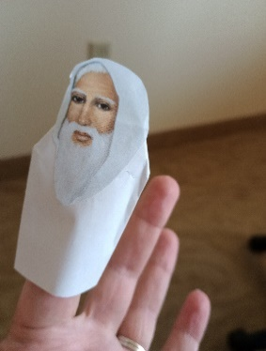Youth go back to their tables to create finger puppets for their ECK Master play. Group Leaders show youth how to make a puppet:
  + Fold in both sides of a paper square and tape it to create a tube.   
    It is okay if the tube is flattened or creased when it is folded.
  + Then fold down the top of the tube and tape it down.
  + Use a glue stick to glue a face on the front of the puppet.
  + Use a blank face to make a puppet of yourself as a future ECK Master. Use markers to draw your face and hair.
  + Use the ECK Master faces to create ECK Master puppets.
  + Use markers to decorate all your puppets’ clothing.
* Youth can each make 3-5 puppets for their play.
* Group Leaders help youth create their play about being of service. Ask youth what they would be like as an ECK Master. Ask youth for their ideas about ways to make things easier for someone else.
* 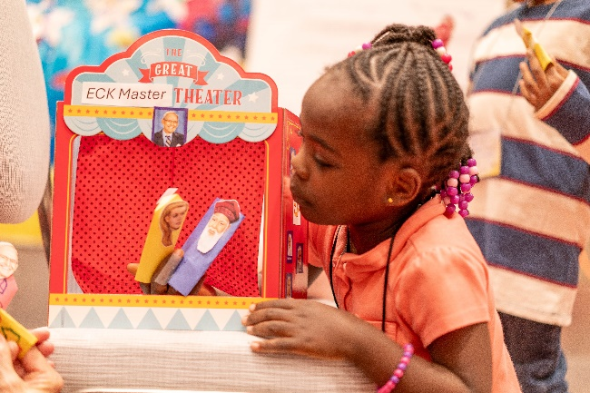Group Leaders can write youth’s ideas for their play on paper. Multiple youth can create one play or youth can create a play to do on their own.

**ECK Master Plays**

* Youth gather on the floor at the front of the room and take turns using the cardboard stage and their finger puppets to put on their plays for other youth.
* The Activity Leader asks youth, *How did you and the ECK Masters in the play help people?*

Break (Get a drink of water, go to the restroom, chat, etc.)

Supplies

* Garden backdrop
* Drapery pins (to hang backdrop)
* Handouts: flower petal, leaf, and stem cut-outs
* Scissors
* Glue sticks
* Markers
* Tape

Gratitude Garden (30 minutes)

* The Activity Leader reviews what ECK Mastership is*: ECK Masters are so full of God’s love that they give that love back to life by helping others. ECK Masters are so grateful for every gift that comes their way.*
* *The seeds of ECK Mastership are in all of us. We can help these seeds grow by filling our hearts with gratitude and love, like ECK Masters do.*
* *We’re going to make a gratitude garden full of flowers.*
* Youth move to tables and choose a gratitude flower handout in a color they like.
* 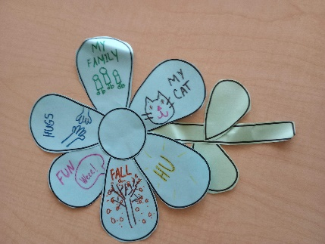Youth write or draw someone or something they are grateful for on each flower petal. Group leaders can offer to help with spelling and writing.
* Youth cut out the parts of their gratitude flower (the petals, stem, and leaves) and then glue their flower together.
* As they finish, a Group Leader gives youth tape and they can go to the garden backdrop hanging in the front of the room and tape their flower to the garden.
* If there is time, youth can make another gratitude flower or play the ECK Master memory game again.

Clean Up, Sharing, and Feedback(15 minutes)

* Youth help clean up the room.
* Youth sit in a large group.
* Room Leader invites youth to share whatever they’d like to about their experience that afternoon.
* Room Leader asks for feedback on the activities they did that day and ideas of what else the youth might want to do in future programs.

? Questions to ask can include but aren’t limited to:

1. What did you like doing today?
2. What could make it even better?
3. What kinds of activities would be fun?
4. What spiritual things do you like to learn about?